**React Basic Things**

**How to Create react app?**

1st , First of all create a folder then open vs code in the folder and then type ( ctrl+` )

To open terminal then type npx create-react-app app_name to create a react app

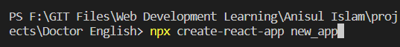

2nd , then type cd app_name to change direction and then type npm start to start the react app

Then , Goto index.js to edit things

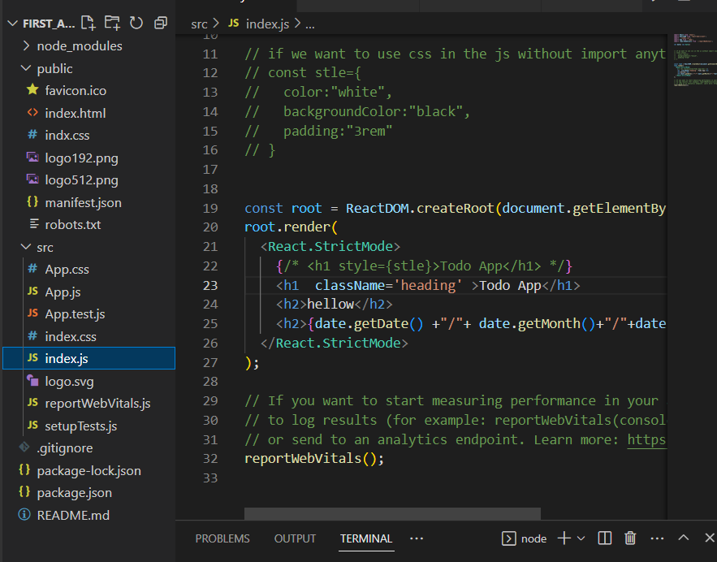

After that edit things in the render file,

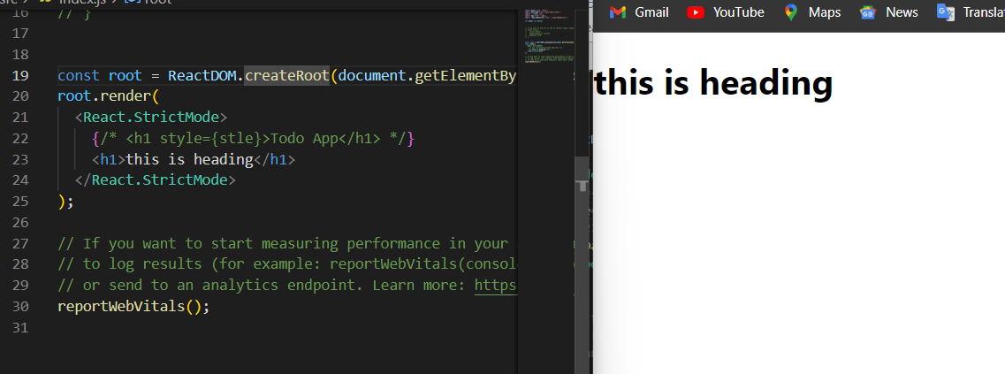

We can edit multiple lines in a code

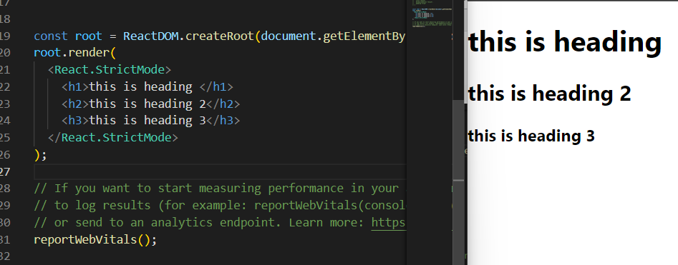

**What is JSX?**

* Jsx stand form javascript xml
* Jsx allows us to add html and css in javascript file

**How to add css in react?**

Two ways to add css in react app

1st , inline

2nd , external

Css inside a javascript file that means it is a internal css

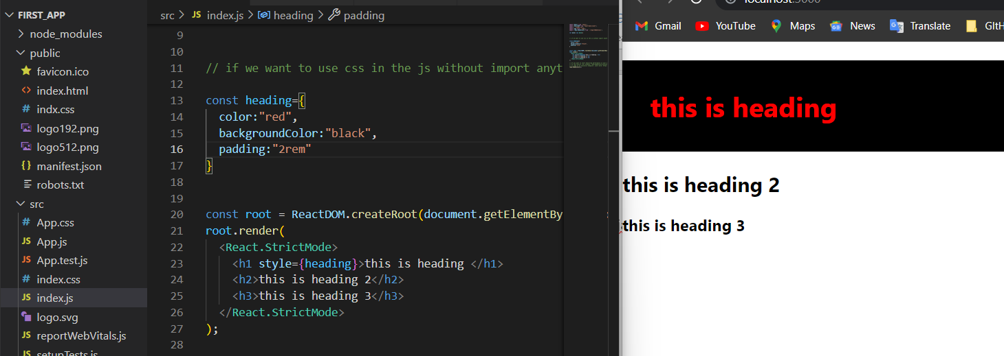

Here we create a object and use it to h1 section

Inline css

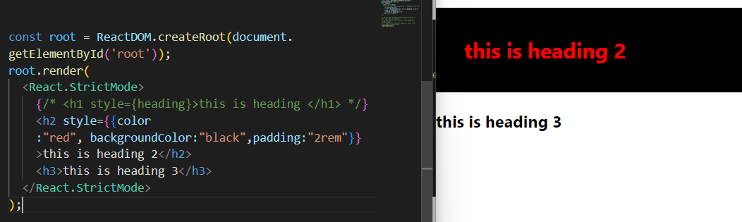

This is inline css and how we can use it

External css=

1. When we create css file in the public folder and link to the html file then we don’t need to import css into the js file in src. We can use it from anywere

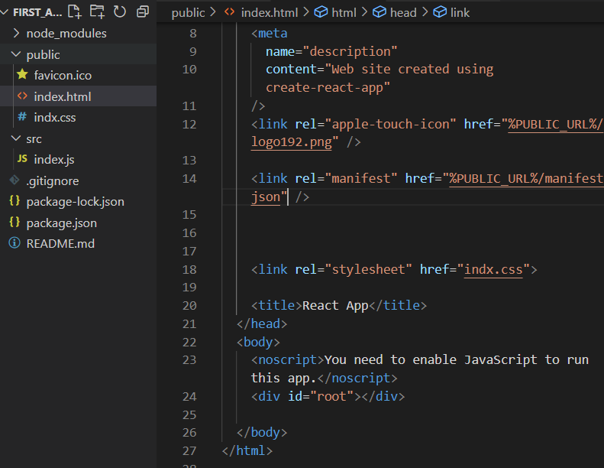

Link the css in the html file in the public folder

after that add the classname we use in the css to edit the appearance

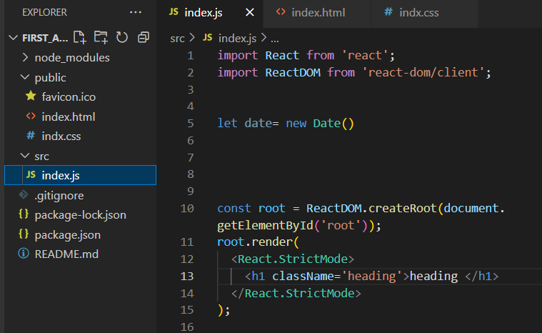

Add the class name without import css file in the js file

Then go to css file and edit as your own

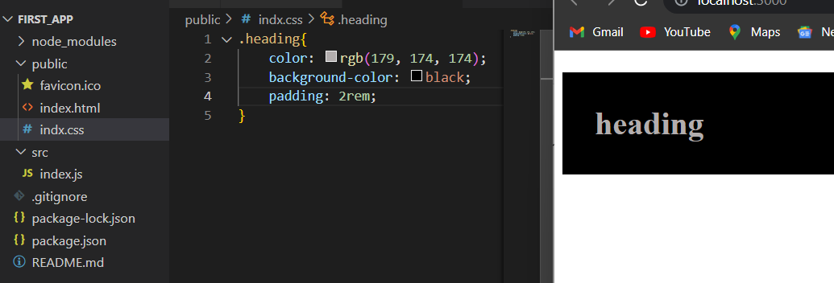

1. Then , if we don’t create css file in the public folder and create css folder in anywhere in the application then we need to import the css file to edit the html code that we want in the javascript file

So first of all create a css file the src folder or anywhere in the application

As indx.css file

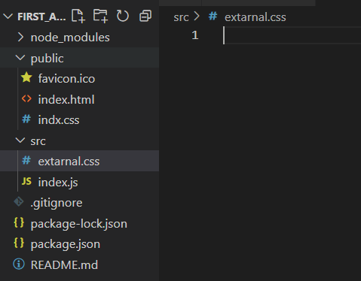

Then import the css file in the js file

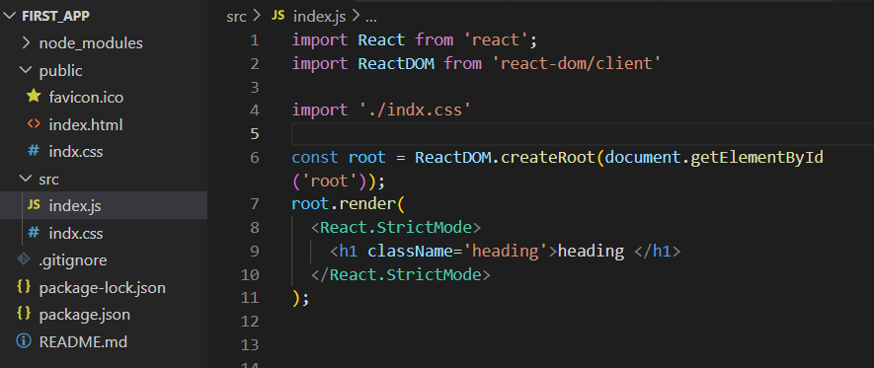

Import the css file and use the classname in the heading section

And then edit the css file and change h1’s appearance

